1. Write a JavaScript program that prints all even numbers from 1 to 20.
2. <!DOCTYPE html>
3. <html lang="en">
4. <head>
5. <meta charset="UTF-8">
6. <meta name="viewport" content="width=device-width, initial-scale=1.0">
7. <title>Document</title>
8. </head>
9. <body>
10. <script>
11. for(let i=2; i<=20;  i+=2)
12. {
13. document.write(i+"<br>");
14. }</script>
15. </body>
16. </html>

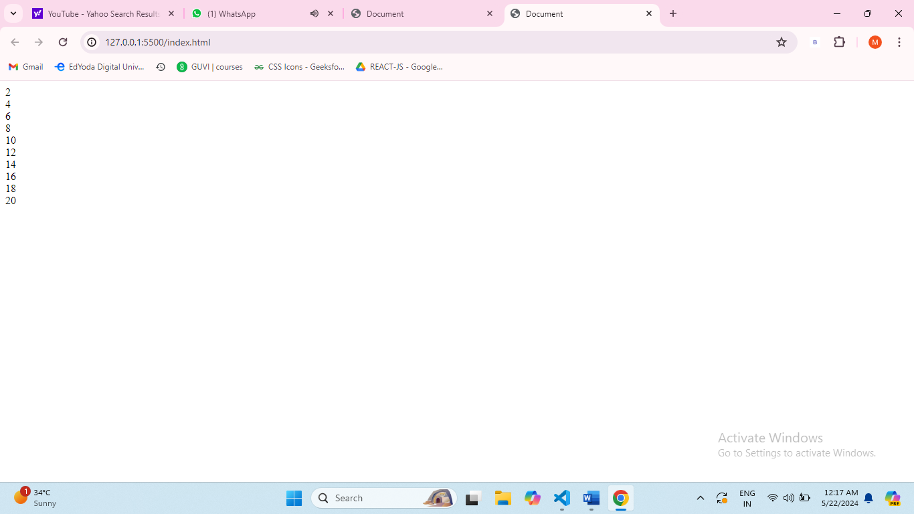

1. Create a JavaScript function that checks if a given number is prime.
2. /\*Create a JavaScript function that checks if a given number is prime.\*/
3. <!DOCTYPE html>
4. <html lang="en">
5. <head>
6. <meta charset="UTF-8">
7. <meta name="viewport" content="width=device-width, initial-scale=1.0">
8. <title>Document</title>
9. </head>
10. <body>
11. <script>
12. function isPrime(number) {
13. if (number <= 1) {
14. return false;
15. }
16. for (let i = 2; i <= Math.sqrt(number); i++) {
17. if (number % i === 0) {
18. return false;
19. }
20. }
21. return true;
22. }
23. const numToCheck = 15;
24. if (isPrime(numToCheck)) {
25. document.write(`${numToCheck} is a prime number.`);
26. } else {
27. document.write(`${numToCheck} is not a prime number.`);
28. }
29. </script>
30. </body>
31. </html>
32. 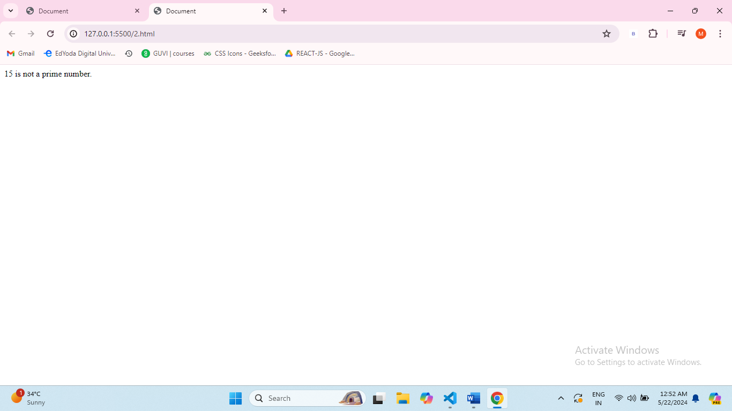
33. Write a JavaScript program to find the largest of three numbers.
34. <!DOCTYPE html>
35. <html lang="en">
36. <head>
37. <meta charset="UTF-8">
38. <meta name="viewport" content="width=device-width, initial-scale=1.0">
39. <title>Document</title>
40. </head>
41. <body>
42. <script>
43. function findLargestNumber(a, b, c) {
44. let largest = a;
45. if (b > largest) {
46. largest = b;
47. }
48. if (c > largest) {
49. largest = c;
50. }
51. return largest;
52. }
53. const num1 = 10;
54. const num2 = 25;
55. const num3 = 15;
56. const result = findLargestNumber(num1, num2, num3);
57. document.write(`The largest number among ${num1}, ${num2}, and ${num3} is ${result}.`);
58. </script>
59. </body>
60. </html>
61. 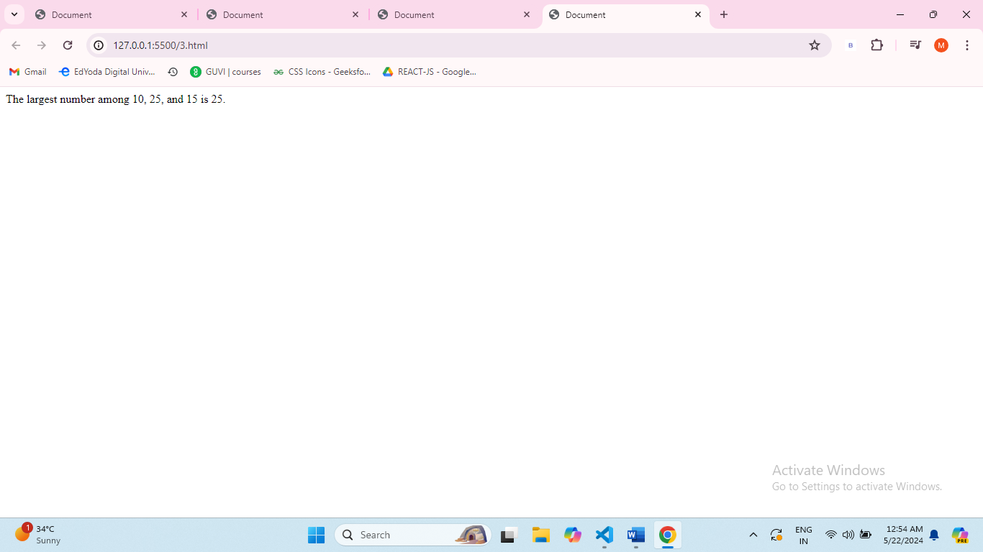
62. Develop a JavaScript function to calculate the factorial of a number using a for loop.
63. <!DOCTYPE html>
64. <html lang="en">
65. <head>
66. <meta charset="UTF-8">
67. <meta name="viewport" content="width=device-width, initial-scale=1.0">
68. <title>Document</title>
69. </head>
70. <body>
71. <script>
72. function calculateFactorial(number) {
73. if (number < 0) {
74. return "Factorial is not defined for negative numbers.";
75. } else if (number === 0 || number === 1) {
76. return 1;
77. } else {
78. let factorial = 1;
79. for (let i = 2; i <= number; i++) {
80. factorial \*= i;
81. }
82. return factorial;
83. }
84. }
85. const inputNumber = 5;
86. const result = calculateFactorial(inputNumber);
87. document.write(`Factorial of ${inputNumber} is ${result}.`);
88. </script>
89. </body>
90. </html>
91. 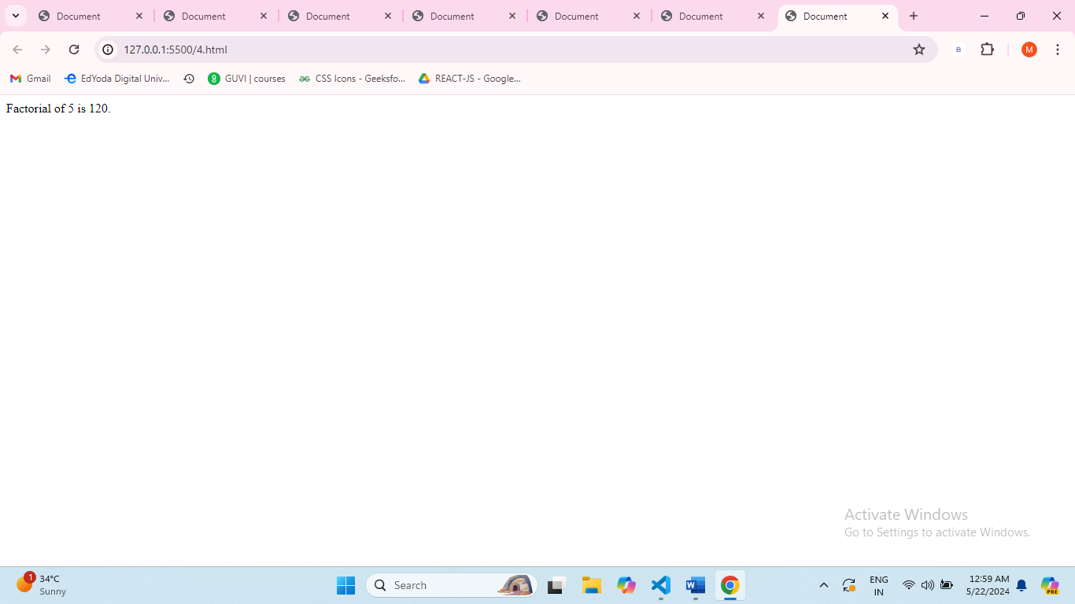
92. Create a JavaScript program that reverses a given string.
93. <!DOCTYPE html>
94. <html lang="en">
95. <head>
96. <meta charset="UTF-8">
97. <meta name="viewport" content="width=device-width, initial-scale=1.0">
98. <title>Document</title>
99. </head>
100. <body>
101. <script>
102. function reverseString(inputString) {
103. const charArray = inputString.split('');
104. const reversedArray = charArray.reverse();
105. const reversedString = reversedArray.join('');
106. return reversedString;
107. }
108. const originalString = "Hello, World!";
109. const reversedResult = reverseString(originalString);
110. document.write(`Original string: ${originalString}`);
111. document.write(`Reversed string: ${reversedResult}`);
112. </script>
113. </body>
114. </html>
115. 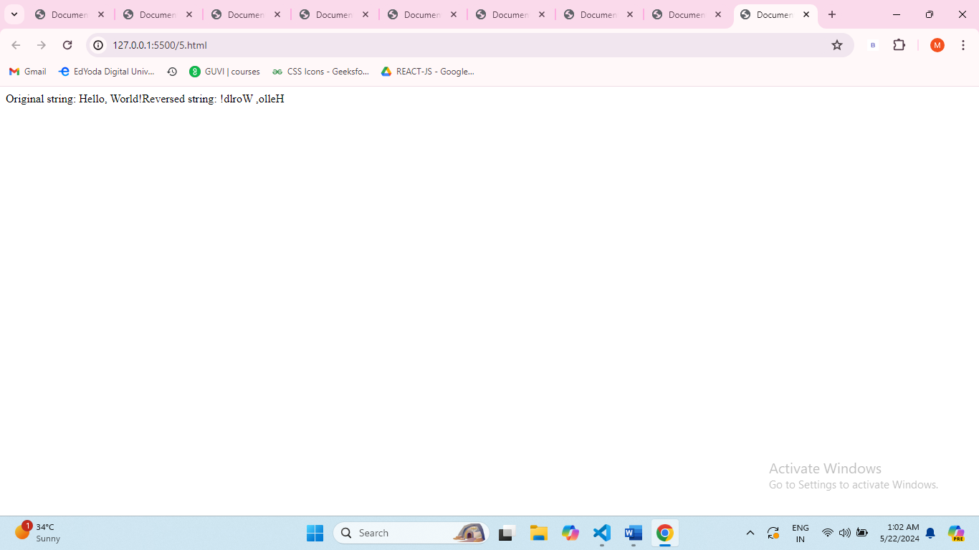
116. Write a JavaScript function that checks if a given string is a palindrome.
117. <!DOCTYPE html>
118. <html lang="en">
119. <head>
120. <meta charset="UTF-8">
121. <meta name="viewport" content="width=device-width, initial-scale=1.0">
122. <title>Document</title>
123. </head>
124. <body>
125. <script>
126. function isPalindrome(inputString) {
127. const cleanedString = inputString.replace(/[^a-zA-Z0-9]/g, '').toLowerCase();
128. const reversedString = cleanedString.split('').reverse().join('');
129. return cleanedString === reversedString;
130. }
131. const testString1 = "racecar";
132. const testString2 = "hello";
133. document.write(`"${testString1}" is a palindrome: ${isPalindrome(testString1)}`);
134. document.write(`"${testString2}" is a palindrome: ${isPalindrome(testString2)}`);
135. </script>
136. </body>
137. </html>
138. 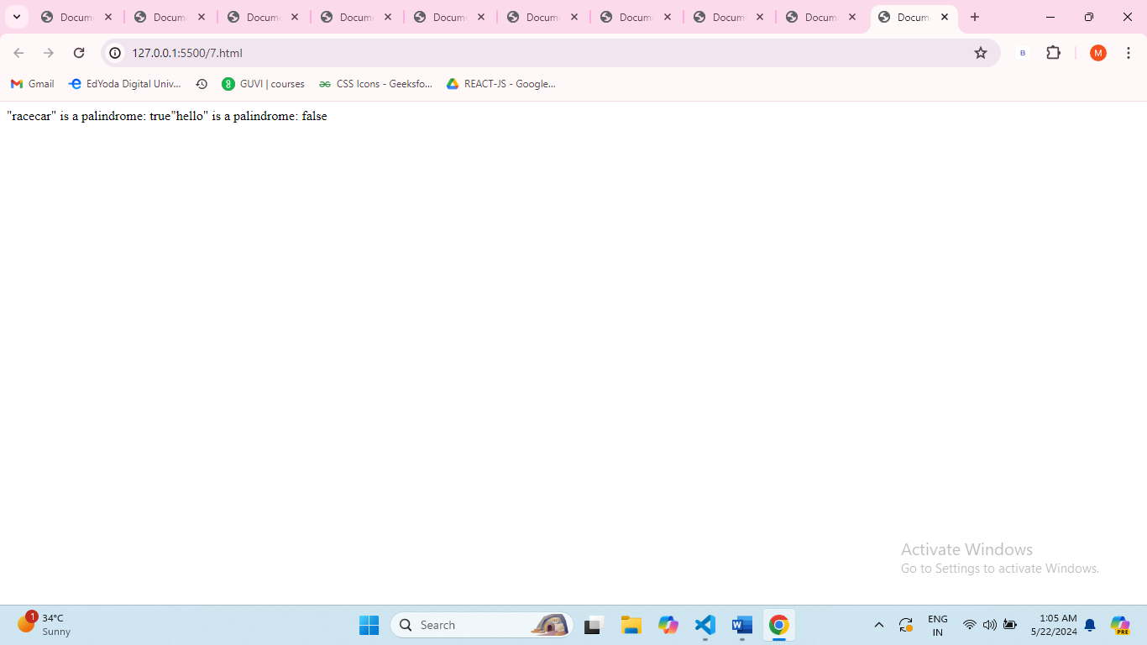
139. Implement a JavaScript program to find the sum of all elements in an array.
140. <!DOCTYPE html>
141. <html lang="en">
142. <head>
143. <meta charset="UTF-8">
144. <meta name="viewport" content="width=device-width, initial-scale=1.0">
145. <title>Document</title>
146. </head>
147. <body>
148. <script>
149. function findArraySum(arr) {
150. let sum = 0;
151. for (let i = 0; i < arr.length; i++) {
152. sum += arr[i];
153. }
154. return sum;
155. }
156. const myArray = [10, 20, 30, 40, 50];
157. const totalSum = findArraySum(myArray);
158. document.write(`The sum of the elements in the array is: ${totalSum}`);
159. </script>
160. </body>
161. </html>
162. 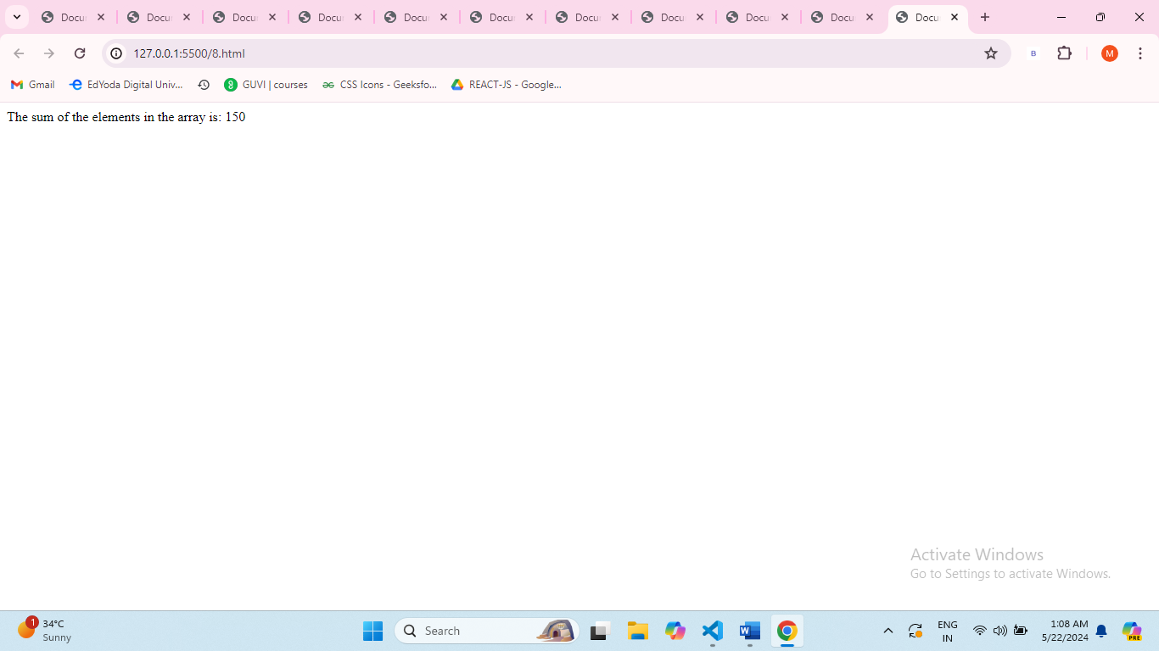
163. Write a JavaScript function to remove duplicates from an array.
164. <!DOCTYPE html>
165. <html lang="en">
166. <head>
167. <meta charset="UTF-8">
168. <meta name="viewport" content="width=device-width, initial-scale=1.0">
169. <title>Document</title>
170. </head>
171. <body>
172. <script>
173. function removeDuplicates(arr) {
174. const uniqueSet = new Set(arr);
175. const uniqueArray = Array.from(uniqueSet);
176. return uniqueArray;
177. }
178. const originalArray = [1, 2, 2, 3, 4, 4, 5];
179. const resultArray = removeDuplicates(originalArray);
180. document.write(`Original array: [${originalArray}]`+"<br>");
181. document.write(`Array with duplicates removed: [${resultArray}]`);
182. </script>
183. </body>
184. </html>
185. 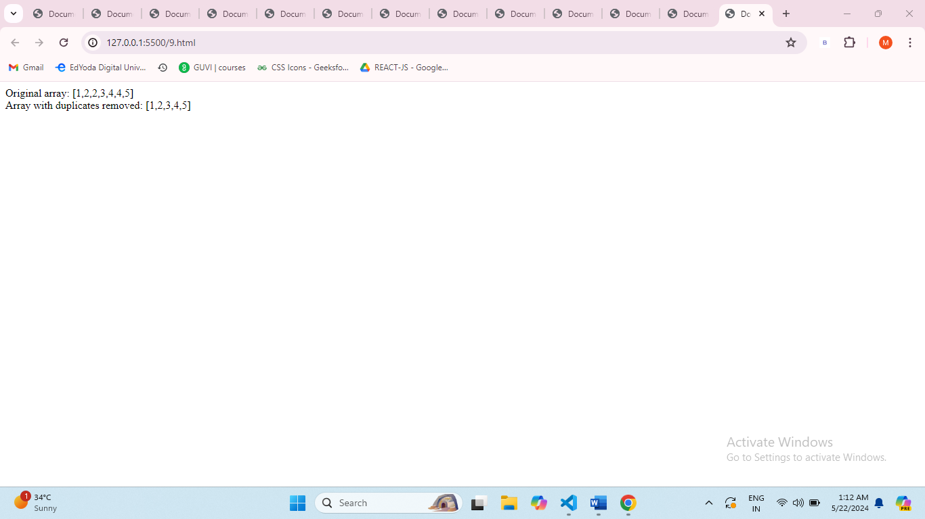
186. Develop a JavaScript program to find the second largest number in an array.
187. <script>
188. function findSecondLargest(arr) {
189. if (arr.length < 2) {
190. return "Array must have at least two elements.";
191. }
192. let largest = arr[0];
193. let secondLargest = arr[1];
194. for (let i = 2; i < arr.length; i++) {
195. if (arr[i] > largest) {
196. secondLargest = largest;
197. largest = arr[i];
198. } else if (arr[i] > secondLargest && arr[i] !== largest) {
199. secondLargest = arr[i];
200. }
201. }
202. return secondLargest;
203. }
204. const myArray = [10, 5, 20, 15, 30];
205. const result = findSecondLargest(myArray);
206. document.write(`The second largest number in the array is: ${result}`);
207. </script>
208. 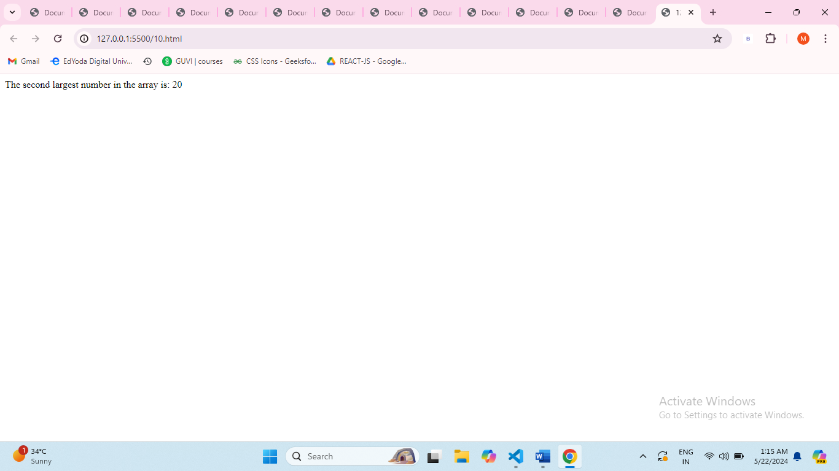
209. Create a JavaScript function that checks if a number is even or odd.
210. <script>
211. function checkEvenOrOdd(number) {
212. if (number % 2 === 0) {
213. return "Even";
214. } else {
215. return "Odd";
216. }
217. }
218. const testNumber = 7;
219. const result = checkEvenOrOdd(testNumber);
220. document.write(`${testNumber} is ${result}.`);
221. </script>
222. 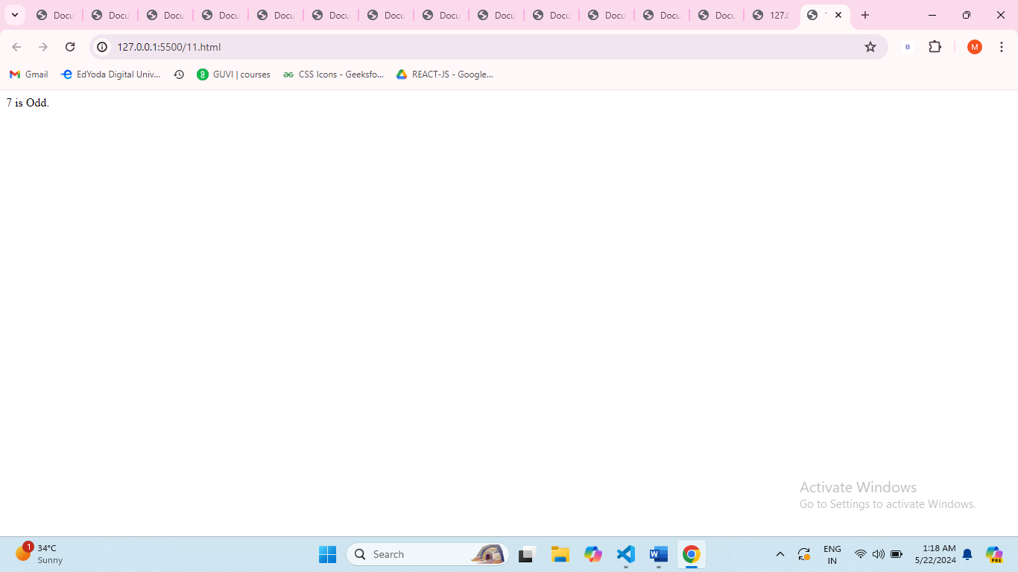
223. Write a JavaScript program to merge two arrays and remove duplicates.
224. <script>
225. function mergeAndRemoveDuplicates(arr1, arr2) {
226. const combinedArray = [...arr1, ...arr2];
227. const uniqueSet = new Set(combinedArray);
228. const mergedArray = Array.from(uniqueSet);
229. return mergedArray;
230. }
231. const array1 = [1, 2, 3, 4];
232. const array2 = [3, 4, 5, 6];
233. const result = mergeAndRemoveDuplicates(array1, array2);
234. console.log(`Merged array with duplicates removed: [${result}]`);
235. </script>
236. 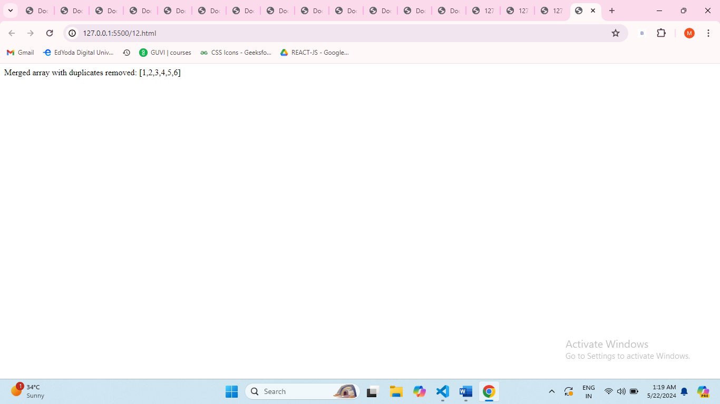

Create a JavaScript function to find the GCD of two numbers using a while loop. <script>

    function findGCD(a, b) {

    a = Math.abs(a);

    b = Math.abs(b);

    while (b !== 0) {

        const temp = b;

        b = a % b;

        a = temp;

    }

    return a;

}

const num1 = 36;

const num2 = 48;

const result = findGCD(num1, num2);

document.write(`GCD of ${num1} and ${num2} is: ${result}`);

</script>

1. 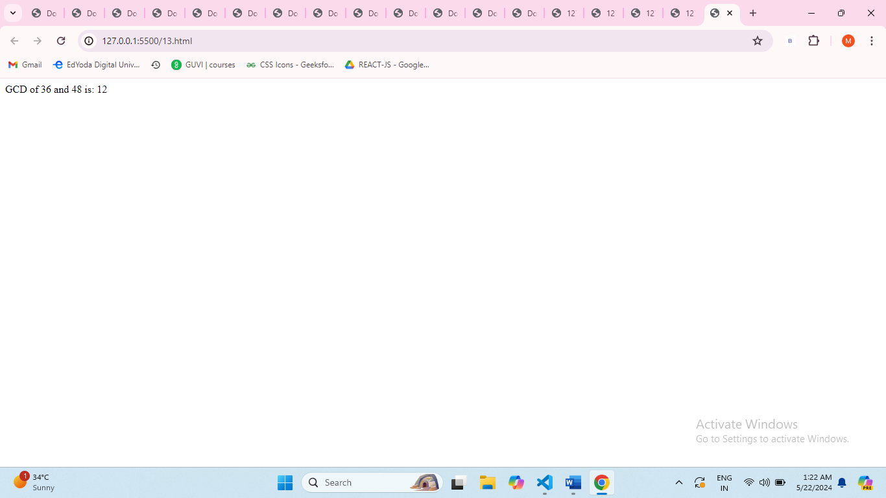
2. Write a JavaScript program to print the Fibonacci series up to a given number.
3. <script>
4. function generateFibonacciSeries(limit) {
5. const fibonacciSeries = [0, 1];
6. while (fibonacciSeries[fibonacciSeries.length - 1] + fibonacciSeries[fibonacciSeries.length - 2] <= limit) {
7. const nextNumber = fibonacciSeries[fibonacciSeries.length - 1] + fibonacciSeries[fibonacciSeries.length - 2];
8. fibonacciSeries.push(nextNumber);
9. }
10. return fibonacciSeries;
11. }
12. const givenLimit = 100;
13. const result = generateFibonacciSeries(givenLimit);
14. document.write(`Fibonacci series up to ${givenLimit}: [${result.join(', ')}]`);
15. </script>
16. 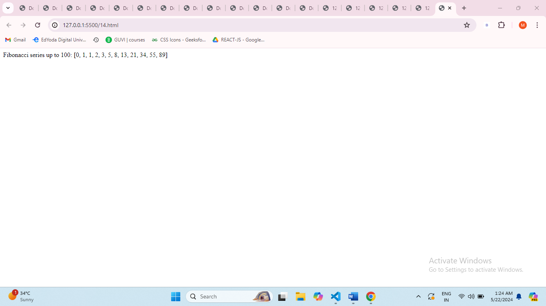
17. Develop a JavaScript function to sort an array of numbers in ascending order.
18. <script>
19. function sortAscending(arr) {
20. arr.sort((a, b) => a - b);
21. return arr;
22. }
23. const myArray = [5, 2, 8, 1, 3];
24. const sortedArray = sortAscending(myArray);
25. document.write(`Sorted array in ascending order: [${sortedArray}]`);
26. </script>
27. 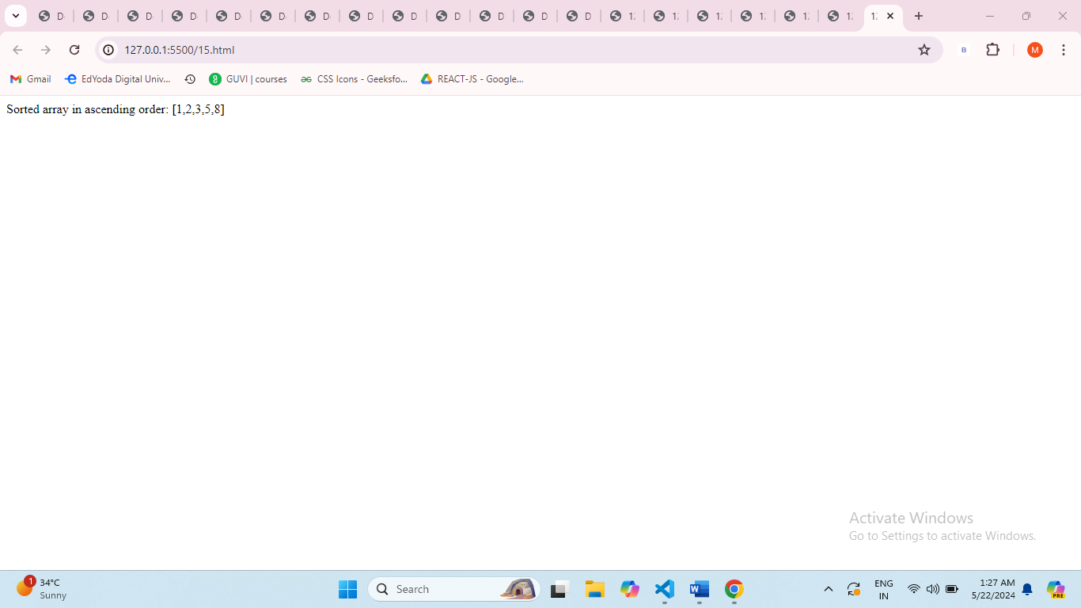
28. Write a JavaScript program to count the number of vowels in a given string
29. <script>
30. function countVowels(inputString) {
31. const vowels = "aeiouAEIOU";
32. let vowelCount = 0;
33. for (let i = 0; i < inputString.length; i++) {
34. if (vowels.includes(inputString[i])) {
35. vowelCount++;
36. }
37. }
38. return vowelCount;
39. }
40. const testString = "Hello, World!";
41. const result = countVowels(testString);
42. document.write(`Number of vowels in "${testString}": ${result}`);
43. </script>
44. 